**Java**

1. Unzip [openjdk-17.0.1\_windows-x64\_bin.zip](https://npc-svc-prod-sdcwpc.emcecs.ntrs.com/npc-svc-prod/openjdk-17.0.1_windows-x64_bin.zip" \t "gsft_link) to C:\Program Files\jdk-17.0.1
2. Add environment variable JAVA\_HOME = C:\Program Files\jdk-17.0.1 (NB – password required)
3. Append to Path environment variable: %JAVA\_HOME%\bin (NB – password required)
4. Restart PC
5. **Test** with command line: **java -version**

**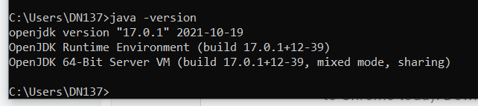**

**Maven**

Unzip apache-maven-3.8.3-bin.zip to C:\Program Files\apache-maven-3.8.3

Add environment variable MAVEN\_HOME = C:\Program Files\apache-maven-3.8.3 (NB – password required)

Add environment variable M2\_HOME = C:\Program Files\apache-maven-3.8.3 (NB – password required)

Append to Path environment variable: %M2\_HOME%\bin (NB – password required)

**Test** with command line: **mvn -version**

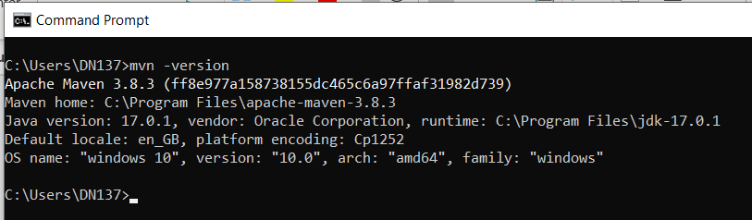

**Eclipse STS**

We’re going to install under **C:\Software** because **C:\Program Files** is a secure location

Extract Eclipse STS (Sprint Tol Suit) jar file with this command

java -jar spring-tool-suite-4-4.13.0.RELEASE-e4.22.0-win32.win32.x86\_64.self-extracting.jar

move to C:\Software\STS

Create a shortcut to C:\Software\STS\ SpringToolSuite4.exe on your desktop, this is your IDE

Copy this **settings.xml** file into your **.m2** folder **C:\Users\{uid}\.m2**



Right-click project, Maven, select maven profile…

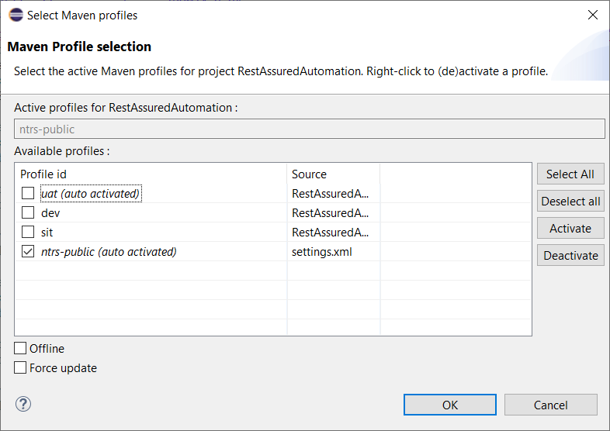

Open the project, right-click -> Maven->Update project

**Cucumber Plugin**

From the IDE… Help-> Install new software

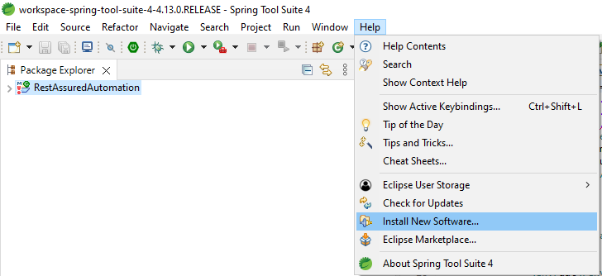

Add … -> Archive

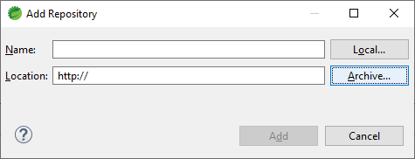

Browse to **cucumber-eclipse-plugin-1.0.0-SNAPSHOT.zip** and install (this will take a few minutes)

**Modify network connection to allow for proxy**

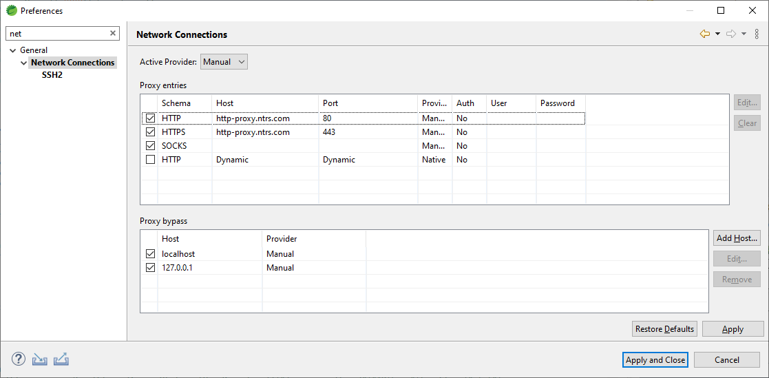

**Lombok**

Open a command line prompt and run the command:

java -jar “C:\Users\{uid}\.m2\repository\org\projectlombok\lombok\1.18.22\Lombok-1.18.22.jar”

**Check** the About dialog to see if Lombok is installed correctly: MainMenu->Help->About Eclipse IDE…

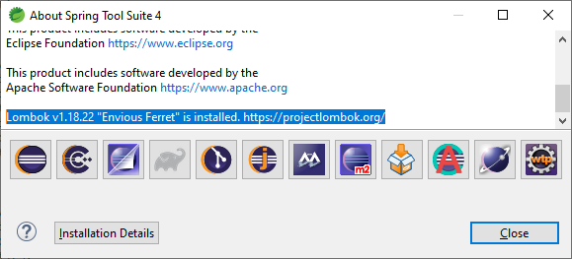

**BitBucket**

From Eclipse IDE, clone an existing repository…

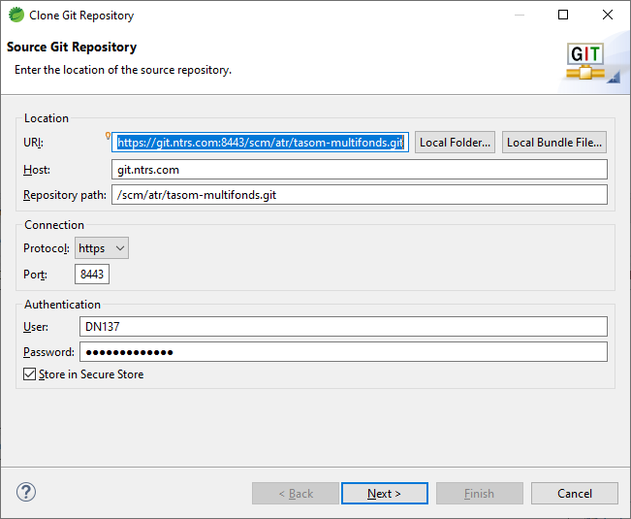

<https://git.ntrs.com:8443/scm/atr/tasom-multifonds.git>

Select Main-Development-Branch only…

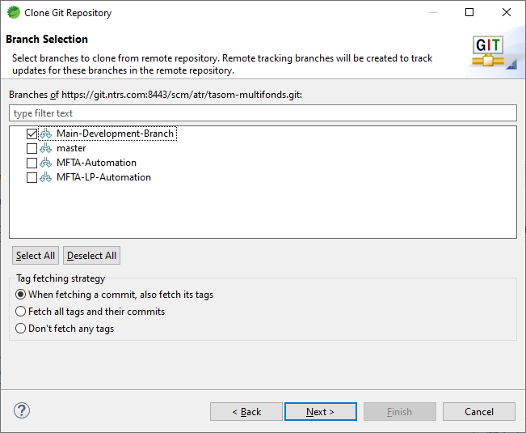

Clone **Main-Development-Branch** to your local C: drive …

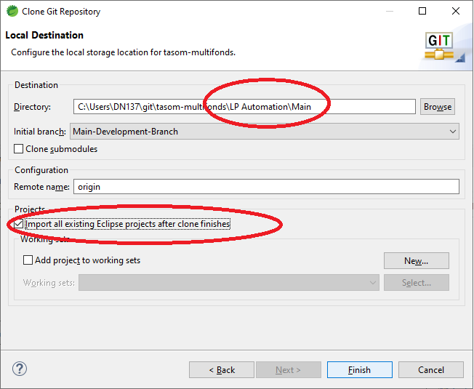

Note: Set your local folder name

Remove any existing projects from Project Explorer…

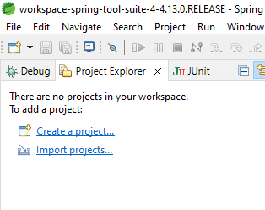

Right-click Main-Development-Branch in **Git Repository** window and select “Import projects”…

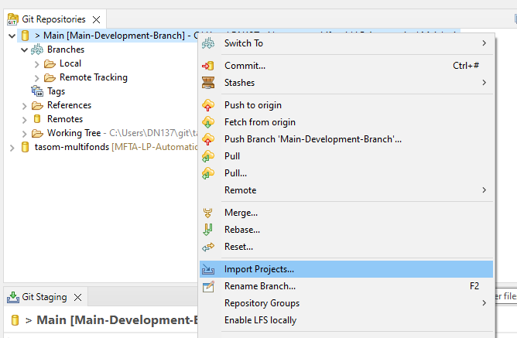

Project is now available in Project Explorer

